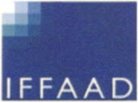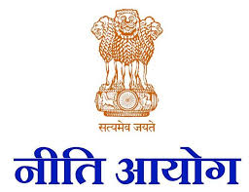
International Foundation
For Aviation pAerospace
And Drones

Subject: Conference India’s ASAT : What Next
Wednesday 17th July 2019 at IIC, New Delhi

09.30 Registration Tea/Coffee
10.00 Inaugural Session Chaired by Prof MS Prasad, Amity University
10.00to 10.10 Introduction by Dr Sanat Kaul

10.10to 10.15 Welcome address by IIC

10.15 to 10.35 Address by Chief Guest Mr Amitabh Kanth
10.35 to 10.55 Keynote Address by Prof Ricky Lee, University of Norte Dame, Australia and Partner at Globalex, Member of MILAMOS Project (Manual on :International Law Applicable to Military Uses of Outer Space) led by the Institute of Air and Space Law, McGill University, Montreal on——
10.55 to 11.05 Coffee/tea break

Session 1 Chaired by Air Marshal Naresh VERMA———
11.05-11.25 Dr Steven Freeland, Prof of International Law, Western Sydney University, Australia- On perspective of the UN Committee on Peaceful Uses of OuterSpace (UN-COPOUS)- via Skype from Tokyo

11.25 to 11.45 Group Capt S. Kushwaha: An overview of ASAT technologies and approaches of various countries.
11.45 to 12.10 Mr Maroof Raza Strategic Affairs Expert with Times Now and TV commentator
12.10 to 12.30 Dr Wing Commander(retd) Dr Ajey Lele: Senior Fellow, Institute of Defence Studies(IDSA) on issues of Space Debris
12.30 to12.50 Air Vice Marshal Sunil Nanodkar:

12.50 to 2.00 pm Lunch

Session II Chaired by Prof M.S. Prasad Amity University ——————
2.00 to 2.20 Dr Ranjana Kaul, Partner Dua Associates, Delhi
2.20 to 2.40 Dr Brahma Chellaney,Professor of Strategic Studies, Centre for Policy Reforms, New Delhi
2.40 to 3.00pm Prof Joseph N Pelton Ph.D formerly Dean of International Space University, Strasbourg, France- via Skype from Strasbourg

3.00 to 3.30 Panel Discussion
3.30 to 3.45 Closing Session
Tea/coffee

retd) Naresh Verma Prof M.S. Prasad Amity Univ

Chairman (IFFAAD) Conference Coordinators

